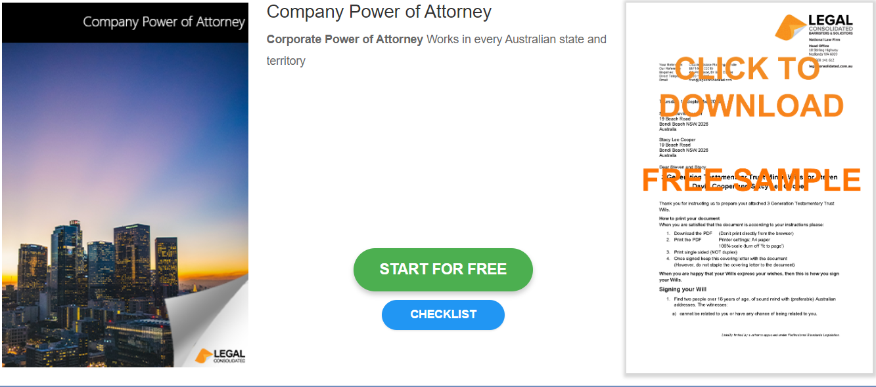

Company Power of Attorney

Start building your document for free:
- Select START FOR FREE - the building process is free: https://legalconsolidated.com.au/corporate-poa-at-death/
- Answer the questions. Read the hints and watch the training videos. Educate and be empowered.
- Telephone the law firm for help answering the questions.
- Select Lock and Build and enter your credit card details.
- Within seconds, you get our cover letter and the finished document.
Company

• Company Name

• Company ACN

• Place of Incorporation

• Date your Company Started

• Company Address
Director

• Director Name

• Director Address
Attorney

•Attorney Name
(ACN if a company)

• Attorney Address

