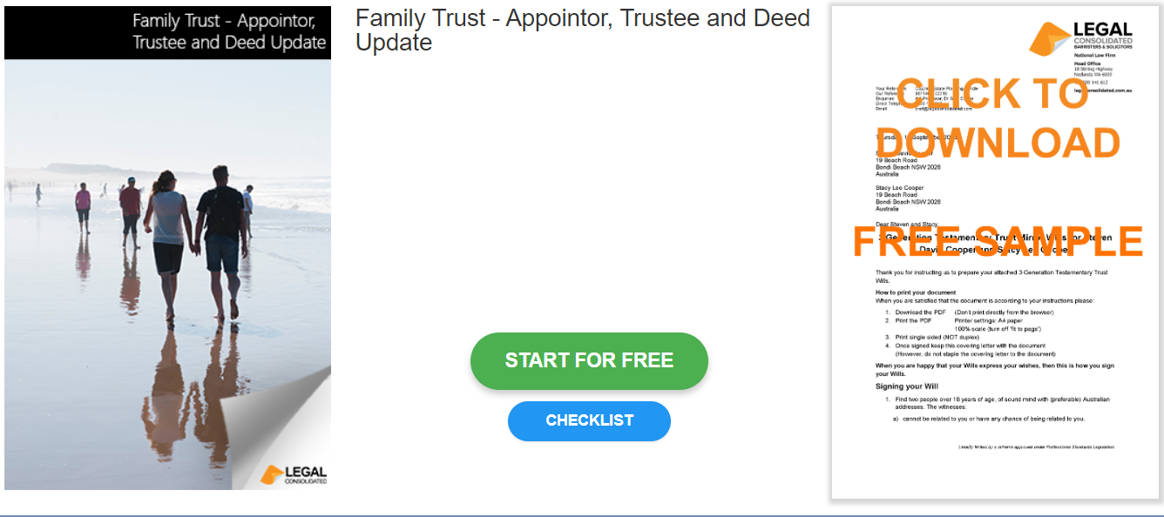

Family Trust – Appointor, Trustee and Deed Update

Start building your document for free:
- Select START FOR FREE - the building process is free: https://legalconsolidated.com.au/family-trust-update-appointor-trustee-deed/
- Answer the questions. Read the hints and watch the training videos. Educate and be empowered.
- Telephone the law firm for help answering the questions.
- Select Lock and Build and enter your credit card details.
- Within seconds, you get our cover letter and the finished document.
Trust Details

•Name of your Family Trust

•Date of original Trust Deed

Appointors Leaving

• Appointors Leaving
(ACN if a company)

• Appointors Leaving
Address
Appointors Staying

• Appointors Staying
(ACN if a company)

• Appointors Staying
Address
Appointors New

• Appointors New
(ACN if a company)

• Appointors New
Address

Back-up Appointors

• Back-up Appointor
(ACN if a company)

• Back-up Appointor
Address

Trustees Leaving

• Trustees Leaving
(ACN if a company)

• Trustees Leaving
Address
Trustees Staying

• Trustees Staying
(ACN if a company)

• Trustees Staying
Address
Trustees New

• Trustees New
(ACN if a company)

• Trustees New
Address

