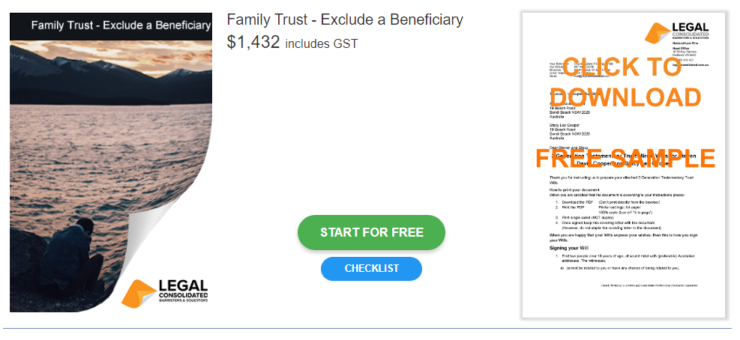

Family Trust Update – Beneficiary Exclusion
Checklist

Start building your document for free:
- Select START FOR FREE - the building process is free: https://legalconsolidated.com.au/family-trust-update-exclude-a-beneficiary/
- Answer the questions. Read the hints and watch the training videos. Educate and be empowered.
- Telephone the law firm for help answering the questions.
- Select Lock and Build and enter your credit card details.
- Within seconds, you get our cover letter and the finished document.
Trust Details

• Name of your Family Trust

• Family Trust Address

• Date the Original Trust Deed Signed

Excluded Beneficiary

• Excluded Beneficiary Name
(ACN if a company)

• Excluded Beneficiary Address

• Date the Original Trust Deed Signed

Settlor

• Settlor Name

• Settlor Address

Outgoing Appointors (if any)

• Outgoing Appointor Name
(ACN, if a company)

Outgoing Appointor Address

Remaining Appointors (if any)

• Remaining Appointor Name
(ACN, if a company)

Remaining Appointor Address

New Appointors (if any)

• New Appointor Name
(ACN, if a company)

New Appointor Address

Backup Appointors (if any)

• Backup Appointor Name
(ACN, if a company)

Backup Appointor Address

Outgoing Trustees (if any)

• Outgoing Trustee Name
(ACN, if a company)

Outgoing Trustee Address

Remaining Trustees (if any)

• Remaining Trustee Name
(ACN, if a company)

Remaining Trustee Address

New Trustees (if any)

• Remaining Trustee Name
(ACN, if a company)

Remaining Trustee Address

