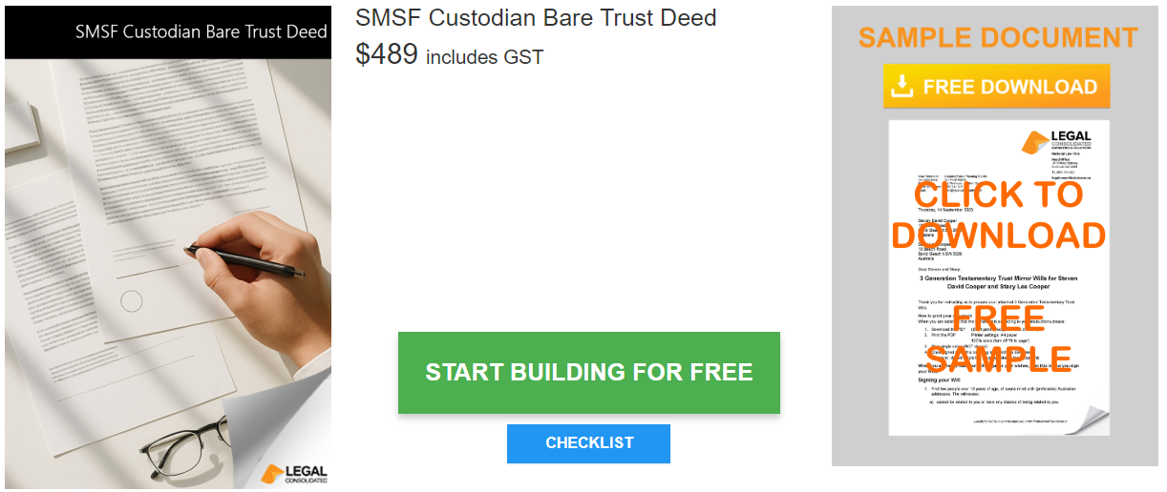

SMSF Custodian Bare Trust Deed

Start building your document for free:
- Select START FOR FREE - the building process is free: https://legalconsolidated.com.au/smsf-custodian-bare-trust-deed/
- Answer the questions. Read the hints and watch the training videos. Educate and be empowered.
- Telephone the law firm for help answering the questions.
- Select Lock and Build and enter your credit card details.
- Within seconds, you get our cover letter and the finished document.
Section / Question (required information) | Your Answers | Notes / Hints
Bare Trustee  • Name of Trustee of the Bare Trust that holds the asset for the SMSF |  | Who runs the SMSF? Usually, this is a Corporate Trustee.  Critical: This entity simply holds the title. It should usually be a "Sole Purpose" company and must not be the same company as the SMSF Trustee
SMSF Trustees  Self Managed Super Fund (Beneficiary) Name  •SMSF ABN (Australian Business Number)  Name of the SMSF's Trustee (company or individual)  (ACN if a company)  SMSF Trustee's Address |  | The SMSF is the "real" owner (Beneficiary).
Vendor  Name of the Vendor  (ACN if a company)  Vendor's Address |  | Who is selling the property to the Bare Trustee?
Bare Trust Asset (Property)  Describe the asset that the Trustee of the Bare Trust will hold for the SMSF  Title Reference (Volume/Folio numbers) |  | The description must be precise. It must be a "Single Acquirable Asset" (e.g., you cannot buy two titles or house and land packages under one bare trust).  Make sure you include the title reference (Volume/Folio numbers).
