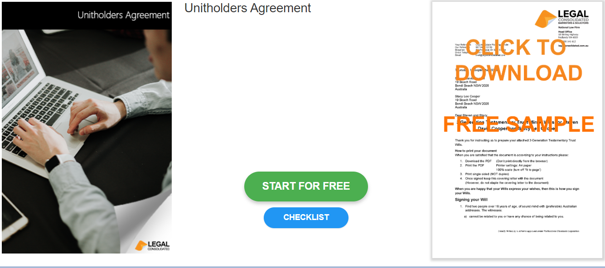

Unitholders Agreement

Start building your document for free:
- Select START FOR FREE - the building process is free: https://legalconsolidated.com.au/unitholders-agreement-introduction/
- Answer the questions. Read the hints and watch the training videos. Educate and be empowered.
- Telephone the law firm for help answering the questions.
- Select Lock and Build and enter your credit card details.
- Within seconds, you get our cover letter and the finished document.

Trust Details

• Name of your current Unit Trust

• Date the Original Trust Deed Signed

Trustee

•Trustee Name
(ACN if a company)

• Trustee Address

Unit Holder

•Unit Holder Name
(ACN if a company)

• Unit Holder Address

Value of Units

•Value of each unit

