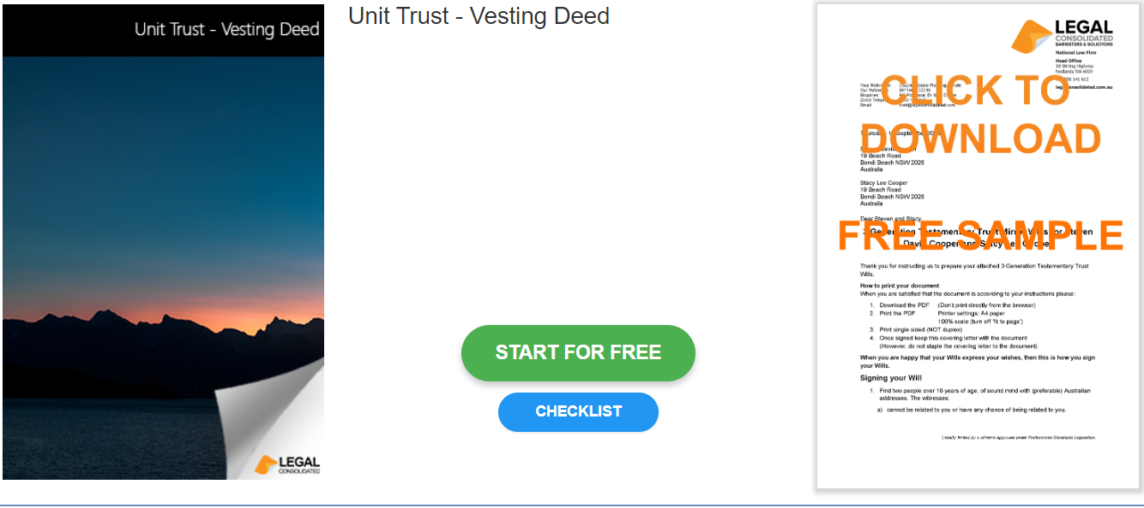

Unit Trust – Vesting Deed

Start building your document for free:
- Select START FOR FREE - the building process is free: https://legalconsolidated.com.au/unit-trust-vesting-deed/
- Answer the questions. Read the hints and watch the training videos. Educate and be empowered.
- Telephone the law firm for help answering the questions.
- Select Lock and Build and enter your credit card details.
- Within seconds, you get our cover letter and the finished document.

Trust Details

• Name of your Trust

• Date the Original Trust Deed Signed

Unit Holders

• Unit Holder Name
(ACN if a company)

• Unit Holder Address

Trustee

•Trustee Name
(ACN if a company)

• Trustee Address

